**MACHINE LEARNING PROJECT**

***In this project ,I have used Linear Regression Machine Learning model for the simple one input feature.***

**PROBLEM STATEMENT:**

***This is the simple example with one input feature using LinearRegression model and SGDRegressor. Create the array into the reshape array.SGD is very sensitive to varying-sized feature values. so first do feature scaling.***

***And also using the fit transform method to SGDRegressor.***

**ML METHODOLAGY :**

***Linear Regression is the methodology used for shaping and reshaping the array.***

***Linear Regression is a machine learning algorithm based on supervised learning. Linear Regression performs the task to predict a dependent variable(y) based on a given independent variable(x). so this regression technique finds out a linear relationship between x(input) and y(output).***

**DATASET DESCRIPTION:**

***Some relevant columns in the dataset***

* ***sgdr coefficient ,weight and intercept values.***
* ***Predict model.***

***PRE_PROCESSING:***

***Pre_processing refers to the transformations applied to our data before feeding it to the algorithm.***

***[1] %matplotlib inline***

***import matplotlib.pyplot as plt***

***import numpy as np***

***from sklearn.linear_model import LinearRegression***

***from sklearn.linear_model import SGDRegressor***

***[2] x=np.array([1,2,4,3,5])***

***Y=np.array([1,3,4,3,7])***

***[3] print(x.shape)***

***print(y.shape)***

***print(x)***

***print(y)***

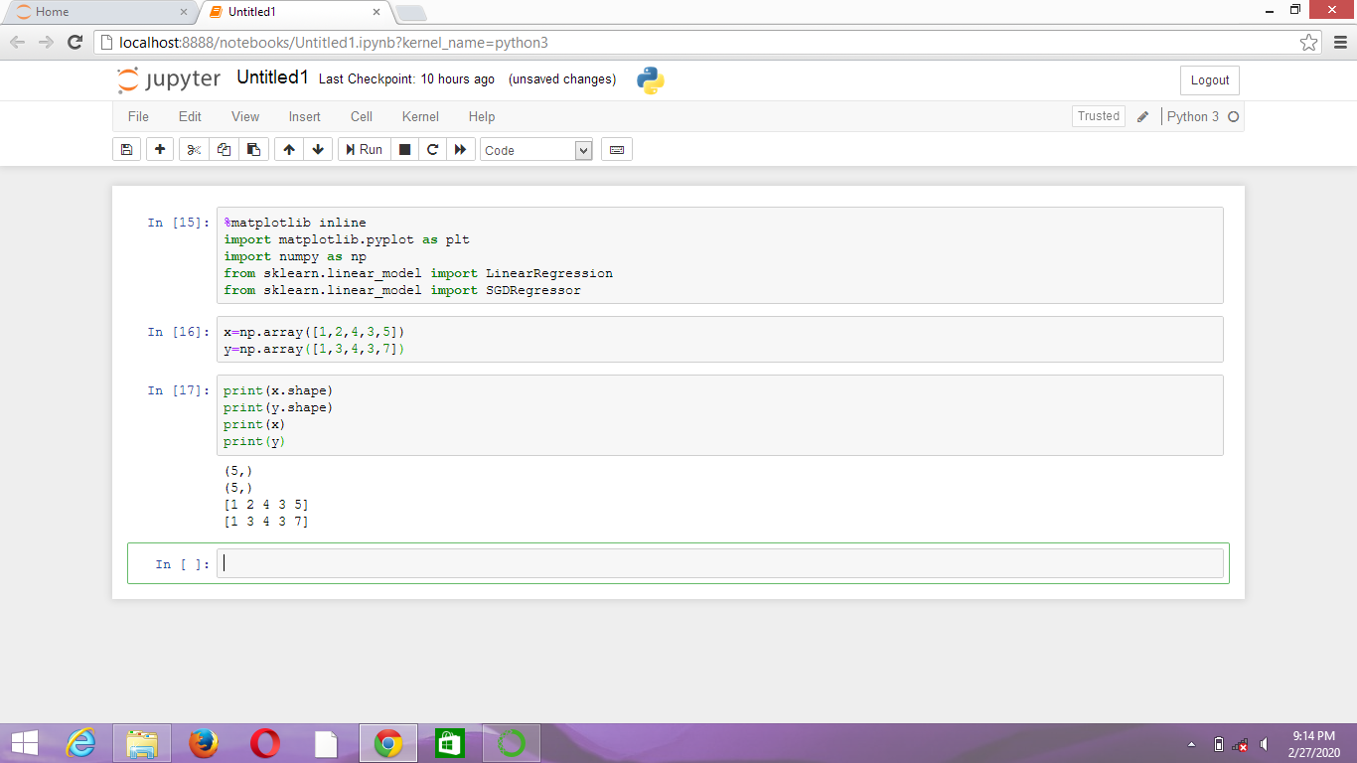

***[4] x=x.reshape(-1,1)***

***print(x.shape)***

***print(x)***

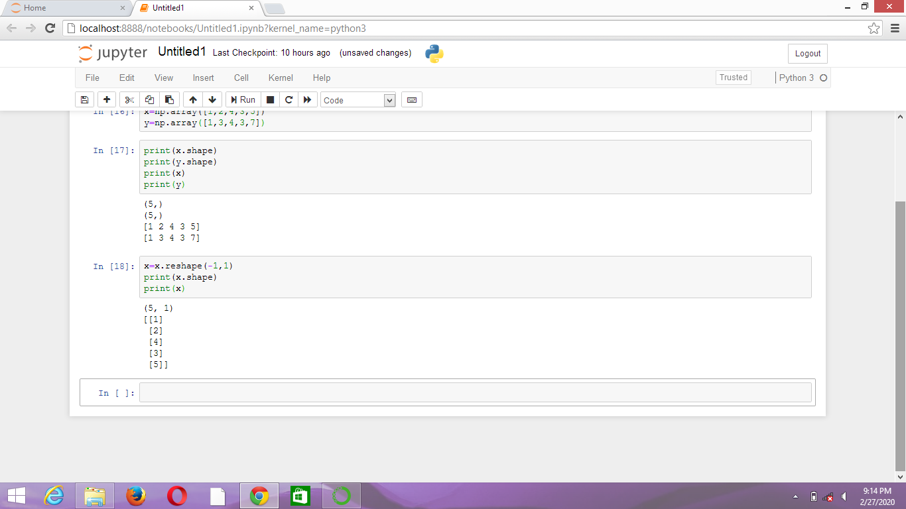

***[5] model=LinearRegression()***

***Model.fit(x,y)***

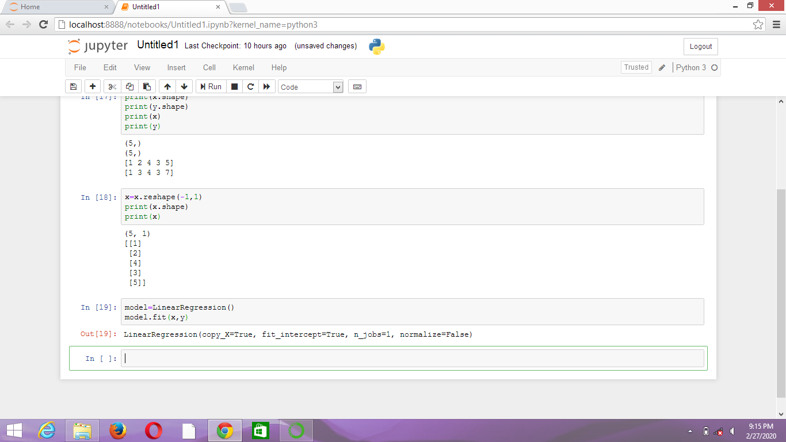

***[6] print(model.predict([[8]])***

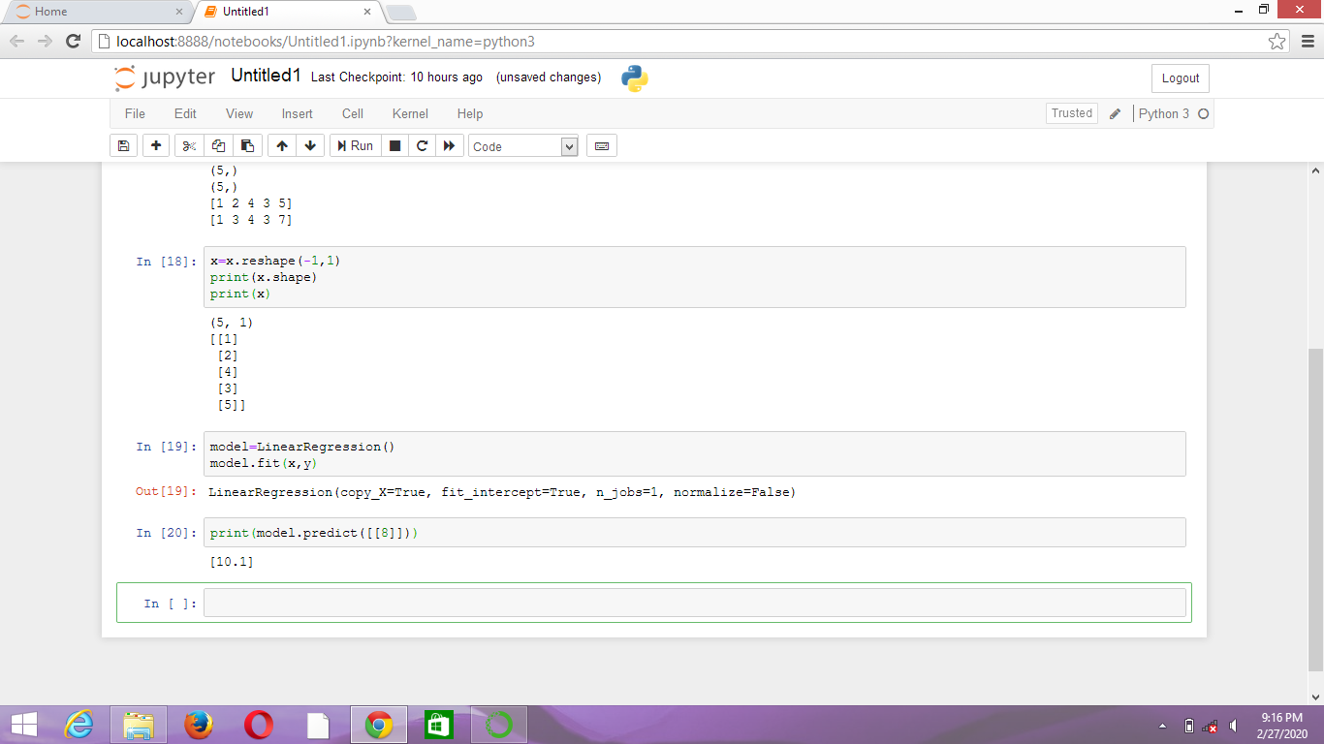

***[7] y_pred=model.predict(x)***

***[8] plt.scatter(x,y,color=’r’,marker=’o’)***

***plt.plot(x,y_pred,color=’b’,linewidth=2)***

***plt.xlabel(‘x’)***

***plt.ylabel(‘y’)***

***plt.show()***

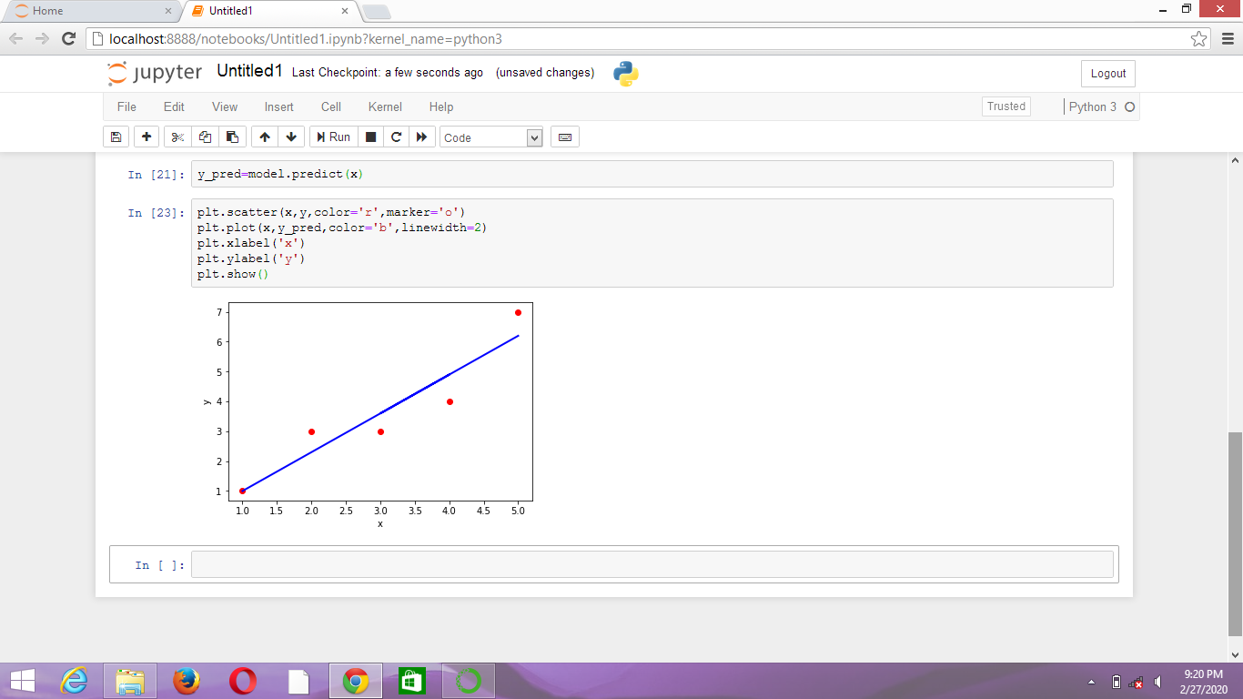

***[9] print(model.coef_)***

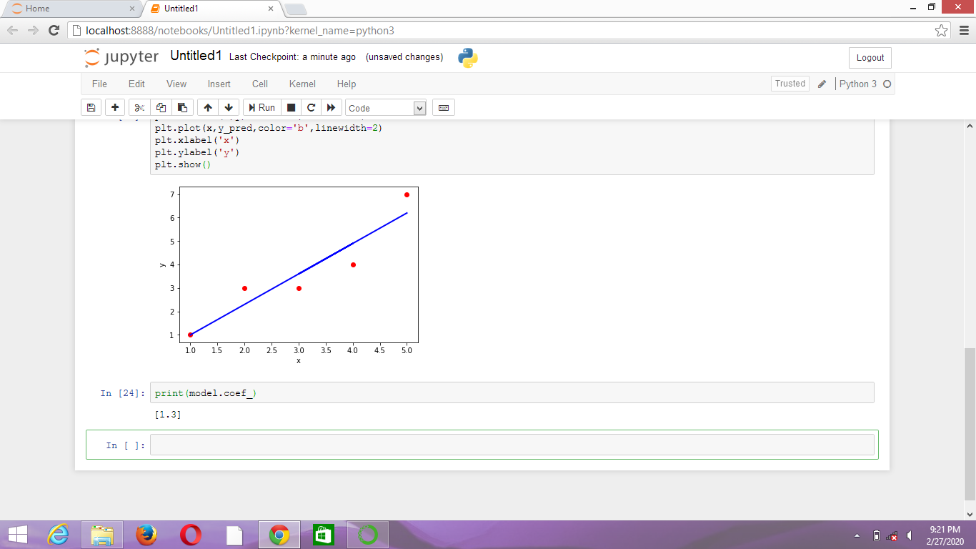

***[10] print(model.intercept_)***

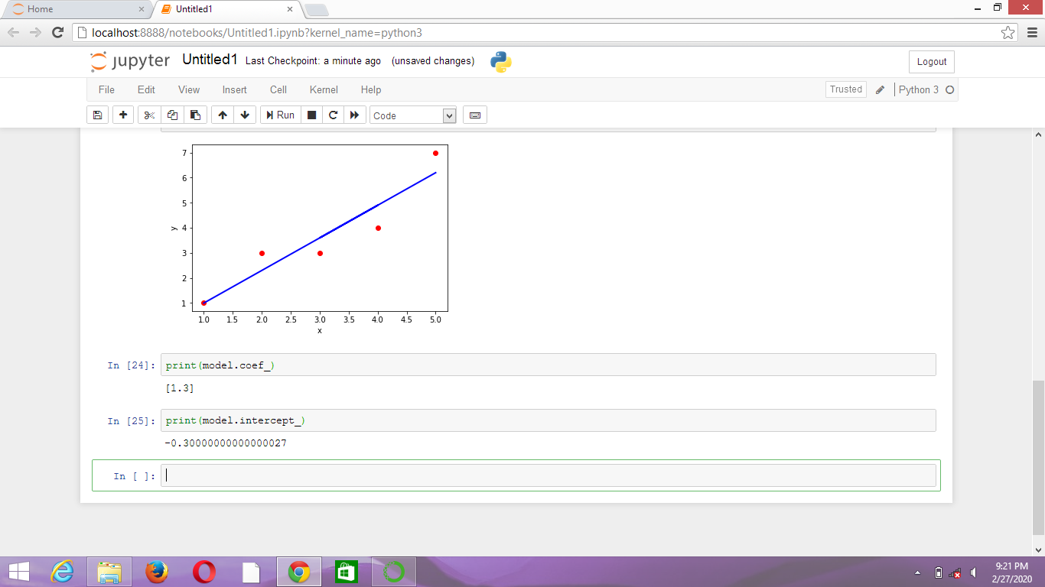

***[11] from sklearn.preprocessing import StandardScaler***

***Scaler=StandardScaler()***

***x_stand=scaler.fit_transform(x.astype(float))***

***[12] sgdr=SGDRegressor(penalty=’l2’,alpha=0.15,max_iter=100)***

***[13] sgdr.fit(x_stand,y)***

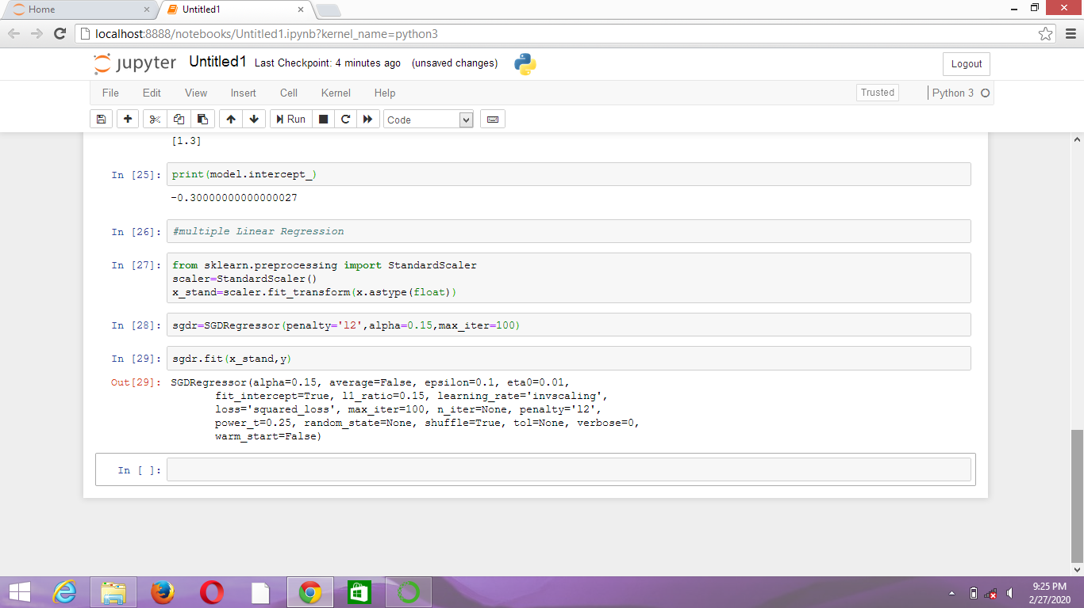

***[14] print(sgdr.predict([[10]])***

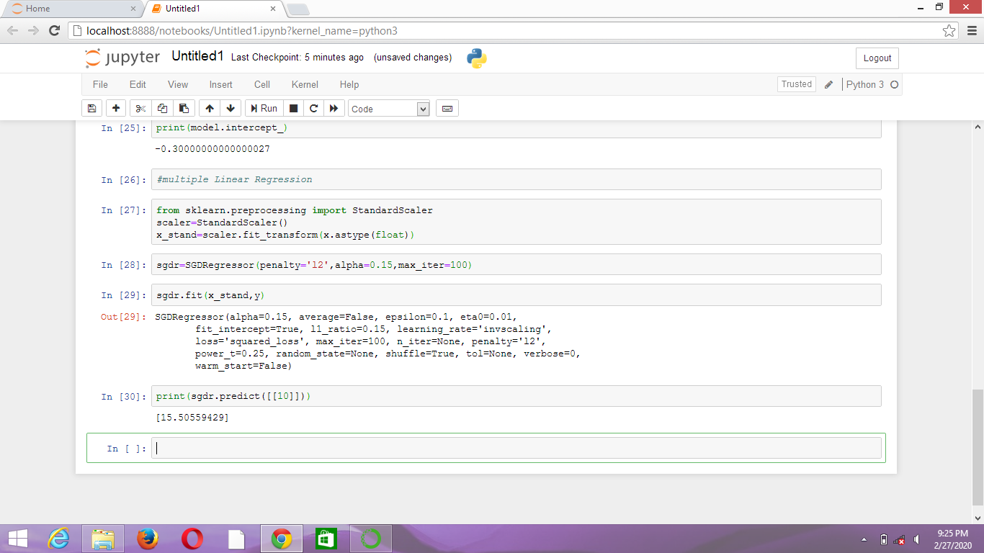

***[15] y_pred2=sgdr.predict(x_stand)***

***[16] plt.scatter(x_stand,y,color=’g’,marker=’o’)***

***plt.plot(x_stand,y_pred2,color=’b’,linewidth=2)***

***plt.xlabel(‘x_normalized’)***

***plt.ylabel(‘y’)***

***plt.show()***

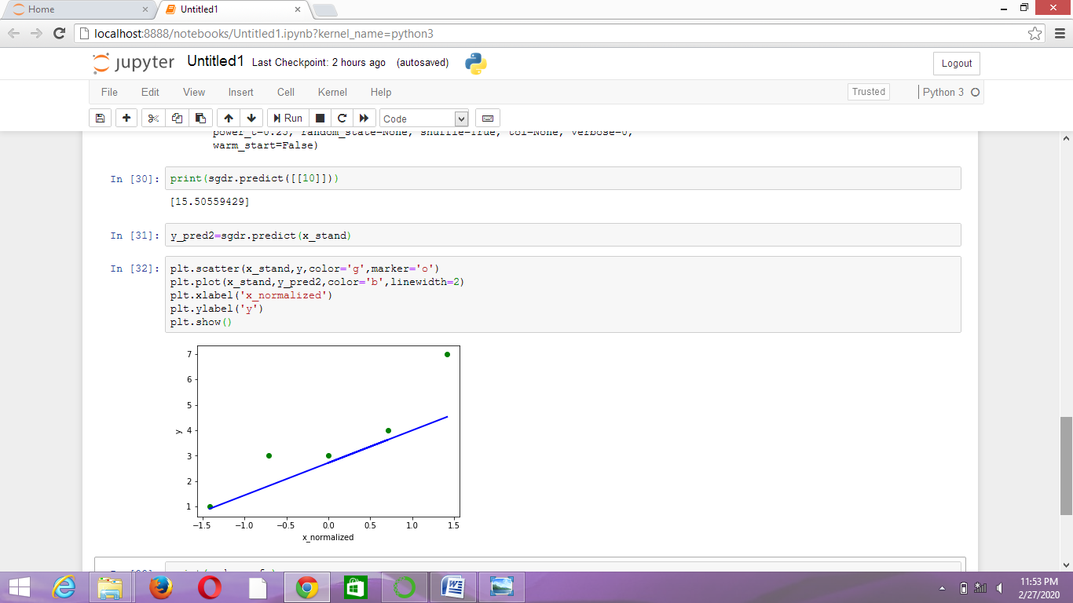

***[17] print(sgdr.coef_)***

***print(sgdr.intercept_)***

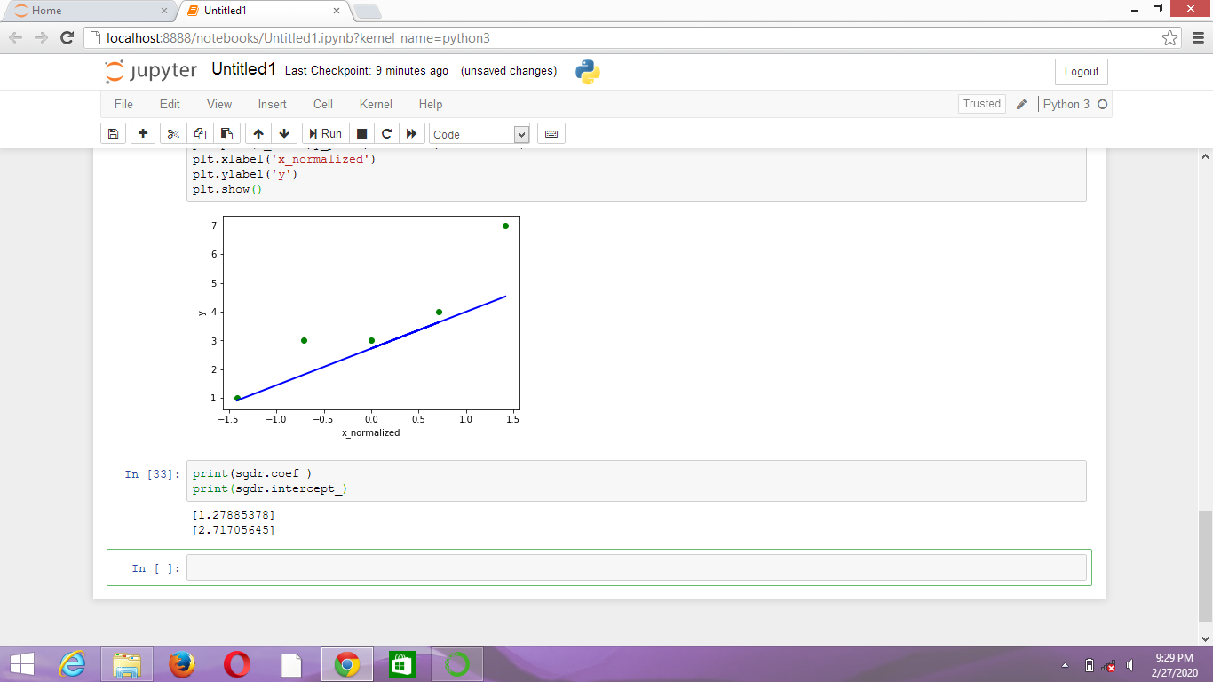

**CONCLUSION:**

***Here the output of weight and intercept of the LinearRegression model.***